Santa Rosa Junior College

Program and Resource Planning Process (PRPP)

**Writer’s Guide**

**Spring 2025**

**ANNUAL PLANNING CYCLE**

**(SECTIONS 2 and 6)**

**Revised February 2024**

**In order to review the data prior to making any budget or staffing requests, it is recommended to review and complete Section 6 prior to completing Section 2.**

**FACULTY STAFFING REPORT**: The Faculty Staffing Committee no longer extracts a report of the following sections of PRPP: 1.2, 2.3a, 2.3b, 2.3c, 2.3d, 2.3e, 5.0, 5.1, 5.2a, 5.2b, 5.3, 5.4, 5.5, 5.9b, 5.11a. Information reported in these sections by academic departments may be used to complete faculty staffing request documents as required by the Faculty Staffing Committee.

**SECTION 1: OVERVIEW**

**1.1 Unit Mission and Description**

**1.1a Mission**

State the program/unit’s mission. If the program/unit doesn’t have one, create one. The mission statement should include the purpose of your program/unit, the ideals the program strives to attain, and whom the program/unit serves (students, staff, community, etc.). 200-word limit.

*Writing Tips: Following are examples of well-written mission statements.*

*Mission of Life Sciences Department: To provide students with a general education in the biological sciences as preparation for college or university transfer, entrance into professional programs in the health sciences, or personal enrichment. The faculty strives to provide a conceptual framework from which students will develop an appreciation and understanding of the designs, functions, and evolutionary uniqueness of the earth’s life forms.*

*Admissions, Records, and Enrollment Development Mission*

*The Admissions, Records, and Enrollment Development services provide critical support for the matriculation and instructional goals of District students. Its primary mission is to ensure open and equitable student access and assure that enrollment, record management and distribution, student confidentiality, grading, attendance accounting and reporting are consistently maintained and updated as state, federal and District policies change.*

**1.1b Mission Alignment**

How is the program/unit mission consistent with the District’s Mission and Strategic Plan Goals?

*NOTE: The Sonoma County Junior College Mission Statement and Strategic Plan Goals and Objectives can be found on the Institutional Planning website at:* [*https://planning.santarosa.edu*](https://planning.santarosa.edu/)*.*

**1.1c Description**

Describe the program/unit's activities, including services provided, and whom the program/unit serves.

*Writing Tips: This description gives the reader an overview of your program/unit. Describe it as you would to an interested outsider who doesn’t really know your program/unit.*

**1.1d Hours of Office Operation and Service by Location**

Describe the program/unit’s hours and days of operation, including staff coverage during those times, at each location.

**1.2 Program/Unit Context and Environmental Scan**

Degree programs, transfer majors, general education, and basic skills:

* Have there been any changes in the transfer requirements for this major, particularly at CSU or UC campuses or at other common transfer destinations in this discipline? If so, describe those.
* Are there trends in industry or technology that could affect this discipline or major?
* Are there new trends in general education or basic skills that affect courses in this discipline or major?
* What partnerships or cooperative ventures exist with local employers, transfer institutions, or other community colleges?

Career and Technical Education (CTE) certificates or majors:

* What significant changes have occurred in the labor market that might impact demand for these courses, certificates or majors?
* What changes are anticipated over the next three years in this industry that might impact instruction?
* Are there any requirements of licensing/accrediting agencies related to this program? If so, please explain.
* What partnerships or cooperative ventures exist with local employers, transfer institutions, other community colleges, or local high schools?
* Has there been an increase or decrease in outside funding resources and/or industry/business support?

Other programs/units

Describe any changes in the social, business, cultural, educational, technological or regulatory environment that could impact your program/unit over the next three years.

*Writing Tips: The purpose of this section is to convey to the reader the “big picture,” highlighting any aspects of the social, business, cultural, educational, technological, or regulatory environment that may impact your program/unit over the next three years or that provide insights into future trends.*

**SECTION 2.0: RESOURCES**

**2.1a Resources: Budget Needs**

In all your responses to the questions in this section, please refer to appropriate information from the **Core Data or your own program/unit budget** to provide evidence. You can also refer to other appropriate sources of evidence such as existing budget printouts from Accounting or the annual budget development worksheet (three year trend). Cite the source of your evidence.

These questions **only** apply to budget categories of 4000s and 5000s (supplies and services). Budgets for faculty and non-faculty staffing will be addressed later.

* Describe areas where your budget might be inadequate to fulfill your program/unit’s goals and purposes.
* If you need additional funds, please explain.

**2.1b Budget Requests**

***Process****:**The purpose of this spreadsheet is to itemize your budget requests in rank order. This table exports to a master spreadsheet that can be sorted by the supervising administrator and the component Vice President. It will be used to determine priorities within the cluster or the component.*

Fill in the chart provided with your specific budget requests using your specific budget codes.

Rank: Assign a numerical ranking (1, 2, 3, 4…). Assign each item a separate rank (do not use any ranking more than once).

Location: Choose from the drop-down menu the location for this request

Strategic Plan Strategy: Choose from the drop-down menu one of the Strategic Plan Strategies.

Goal Alignment: Choose from the drop-down menu one of the focus areas from the Strategic Plan Goals.

*NOTE: The Sonoma County Junior College Mission Statement and Strategic Plan Goals and Objectives can be found on the Institutional Planning website at:* [*https://planning.santarosa.edu*](https://planning.santarosa.edu)*.*

Amount: State the approximate dollar amount, but do not type the dollar sign ($)

Brief Rationale: Very briefly state the rationale. This information exports to a master spreadsheet, so keep it brief.

**2.2 Classified, Management, STNC, and Student Worker Staffing**

**2.2a Current Classified Positions**

Fill out the table to describe your **current** classified staff.

Position: Use the accurate position title.

Hours per week: Enter the typical or average hours per week.

Months per year: Enter the months per year, typically 10, 11, or 12 months

Job Duties (Brief): Be brief and concise. This information exports to a master spreadsheet.

*Writing Tips: The purpose of 2.2a is simply to list and describe the current classified staff in the program/unit. If you request additional staffing, others will need to understand your current staffing configuration. The* ***Core Data*** *provides you with a list of positions. This list is provided to help you fill out the tables. If there are anomalies or glitches in the* ***Core Data****, don’t worry about that. For example, there might be a small, retroactive pay amount for an employee who no longer works in your area; this is not important.* ***Just list the accurate information in your PRPP****. Provide brief descriptions that will help a person unfamiliar with your program understand the program’s existing classified staffing support. Identify and describe the positions, but* ***do not list the names of individuals****. If you are not sure of job duties or official job title, check the Human Resources web site* [*www.santarosa.edu/hr*](http://www.santarosa.edu/hr) *for exact title and job description.*

**2.2b Current Management/Confidential Positions**

Fill out this table to describe your **current** management and confidential positions.

Position: Use the accurate position title.

Hours per week: Enter the typical or average hours per week.

Months per year: Enter the work year, typical 10, 11, or 12 months

Job Duties (Brief): Be brief and concise. This information exports to a master spreadsheet.

*Writing Tips: The purpose of 2.2b is simply to list and describe the current management and confidential positions in the program/unit. If you request additional staffing, others will need to understand your current staffing configuration. The* ***Core Data*** *provides you with a list of positions. The list is provided to help you fill out the table. If there are anomalies or glitches in the* ***Core Data****, don’t worry about that.* ***Just list the accurate information in your PRPP.*** *For example, if a person has retired and has not yet been replaced, list that position as “vacant.” Provide brief descriptions that will help a person unfamiliar with your program understand the program’s current management and confidential staffing support. Identify and describe the positions, but* ***do not list the names of individuals****. If you are not sure of job duties or official job title, check the Human Resources web site* [*www.santarosa.edu/hr*](http://www.santarosa.edu/hr) *for exact title and job description.*

**2.2c Current STNC/Student Worker Positions** **(Optional)**

Fill out this table to describe your **current** STNC and student workers.

Position: Use the accurate position title.

Hours per week: Enter the typical or average hours per week.

Months per year: Enter the work year, typical 10, 11, or 12 months

Job Duties (Brief): Be brief and concise. This information exports to a master spreadsheet.

*Writing Tips: The purpose of 2.2c is simply to list and describe the current STNC and Student Workers in the program/unit. If you request additional staffing, others will need to understand your current staffing configuration. The* ***Core Data*** *provides you with a list of positions. The list is provided to help you fill out the table below. If there are anomalies or glitches in the* ***Core Data****, don’t worry about that****. Just list the accurate information in your PRPP.*** *Provide brief descriptions that will help a person unfamiliar with your program understand the program’s existing STNC and Student Workers. Identify and describe the positions, but* ***do not list the names of individuals****. It is OK to combine positions when that makes sense. For example if a program normally schedules 35 hours a week of student help, it may not matter whether that is one, two or three different students. You can combine those into one item. If you are not sure of job duties or official job title, check the Human resources web site* [*www.santarosa.edu/hr*](http://www.santarosa.edu/hr) *for exact title and job description.*

**2.2d Adequacy and Effectiveness of Staffing**

Refer to your lists of existing employees provided in the **Core Data** (on the PRPP website). In reference to that and your own experiences, answer the following questions:

• Does the program have adequate classified, management, STNC staff, and student workers to support its needs? If not, explain program/unit needs.

• Does your program/unit have any unfilled vacancies or positions that have been eliminated? If so, how are you accomplishing the work that must be performed? What impact does this have on your program/unit?

**2.2e Classified, Management, STNC and Student Worker Staffing Requests**

List any new or unfilled positions needed by the program/unit. **You no longer need to provide cost estimates for these positions. Top ranking positions will be costed out at the time they are being considered for approval.**

Rank: Assign a numerical ranking (1, 2, 3, 4…). Assign each position a separate rank (do not use any ranking more than once except to group related positions).

Location: Location where this position will be assigned

Strategic Plan Strategies: Choose from the drop-down menu one of the Strategic Plan Strategies.

Goal Alignment: Choose from the drop-down menu one of the focus areas from the Strategic Plan Goals.

*NOTE: The Sonoma County Junior College Mission Statement and Strategic Plan Goals and Objectives can be found on the Institutional Planning website at:* [*https://planning.santarosa.edu*](https://planning.santarosa.edu/)*.*

Current Position Title (if any): If you are proposing a change to an existing position, specify the current position title including FTE and months per year.

Proposed Position Title: If you are proposing a new position, specify the title of that position including FTE and months per year.

Type: Choose from the drop-down menu the type of position (Classified, Management, Student, STNC)

**2.3a Current Contract Faculty Positions**

Position: Identify all **existing** faculty positions, and be specific if positions are specialized.

Description: Provide a brief description of the critical teaching duties of this position, especially any unique duties such as primary responsibility a specific area of the curriculum or any duties unique to the position.

*Writing Tips: This information is important for faculty staffing requests. Describe existing positions in a way that the Faculty Staffing Committee would find useful to understand your current faculty configuration. A list of current contract (“regular” or full-time) is provided in the* ***Core Data*** *to help you. If the list is not accurate (for example, a recent retirement is not reflected), do not worry about it. List the accurate information in your PRPP.*

*You do not need to list each position separately. For example if there are eight instructors in art, anchoring several different studios, and two of those are painting instructors, you could list: “Studio Art: Painting (x 2).” If positions are more generic and all instructors are expected to teach the full range of curriculum, a more generic notation is fine; for example, if there are 22 English instructors who are all generalists, you could list: “English, generalist (x 22).”*

**2.3b Full-time and Part-Time Ratios**

* Enter each discipline in the program/unit.
* How many adjunct faculty are currently in your department (indicate totals by location)?
* For each discipline, type in the full time equivalent faculty (FTEF) and % of teaching load performed by full-time faculty members as part of their **contract** (regular) load.
* For each discipline, type in the full-time equivalent **hourly** faculty (FTEF) and % of teaching load performed by **hourly** faculty members. Note: a full-time faculty overload is considered a part-time or hourly assignment.

Data Source: Full-time, part-time ratio data provided by Academic Affairs (see Academic Affairs Docs folder on PRPP website).

*Writing Tips: This is important information for faculty staffing requests. These full-time and part-time faculty loads and percentages are provided by Academic Affairs each year. Student Services must generate its own data for non-teaching loads. These data include only* ***instructional*** *loads. These data exclude reassigned time (such as chair reassigned time) and other reassigned time assignments (such as Museum Director). “Non conforming load” is typically full-time faculty overload submitted on a PAF, such as “certificated other assignment” or a clinical nursing rotation. These data provide only a “snapshot” of a given semester, and could be misleading if any full-time faculty are on leave (such as medical leave or sabbatical). If this is the case, you may need to correct the data or go back to the data from an earlier year. These data are important for the faculty staffing committee because very low percentages of full-time faculty teaching load may indicate a need for more full-time positions.*

**2.3c Faculty Within Retirement Range**

Do you anticipate that retirements within the next three years may impact your need for faculty staffing?

*Writing Tips: This data may be important to faculty staffing requests. It also may highlight the fact that departments need to plan for retirements and need to pass along important program/unit knowledge and pedagogy. The retirement range data is provided without reference to individuals. Refer to individuals only by position.* ***Do NOT mention an individual’s name or speculate on their retirement status*** *unless an individual has already submitted his/her intention to retire in writing.*

**2.3d Analysis of Faculty Staffing Needs and Rationale to Support Requests**

NOTE: Academic departments that request a faculty position may want to use this section as a repository for Faculty Staffing Committee Narrative Summaries (completed each fall), along with other relevant information not contained in their Narrative Summary.

Complete instructions on Faculty Staffing can be found on the Faculty Staffing Committee website (go to the SRJC website, click on Administration, Committees and Councils, Presidents Advisory Committees, Faculty Staffing, then scroll down to the Faculty Staffing Documents for the current year). The direct link is: <https://bussharepoint.santarosa.edu/committees/faculty-staffing/SitePages/Committee%20Home%20Page.aspx>

**2.3e Faculty Staffing Requests**

Rank: Assign a numerical ranking (1, 2, 3, 4…). Assign each position a separate rank (do not use any ranking more than once).

LOC: Location where this faculty position will be assigned.

Strategic Plan Strategies: Choose from the drop-down menu one of the Strategic Plan Strategies.

Goal Alignment: Choose from the drop-down menu one of the focus areas from the Strategic Plan Goals.

*NOTE: The Sonoma County Junior College Mission Statement and Strategic Plan Goals and Objectives can be found on the Institutional Planning website at:* [*https://planning.santarosa.edu*](https://planning.santarosa.edu/)*.*

Discipline Specialty Area: Specify the specialty area within the discipline, if appropriate.

SLO Assessment Rational: Indicate how this faculty position will assist in the accomplishment of department/discipline SLOs.

**2.4 Equipment and Technology Needs**

Definitions

Equipment – Tangible property with a purchase price of at least $200 and a useful life of more than one year, other than land or buildings and improvements thereon.

Technology – Powered and Computerized; may be connected to a network. Not software. $200 per unit or greater value.

Supply (NOT ALLOWED in 2.4) – A material item of an expendable nature that is consumed, wears out, or deteriorates in use; or one that loses its identity through fabrication or incorporation into a different or more complex unit or substance.

Software (2.4F) – Not equipment. Programs and other operating systems that require licenses.

Instructions for request tables:

1. Rank for Instructional Equipment: Assign a numerical ranking that begins with the number 1 (1, 2, 3…). Assign each item a separate rank. DO NOT rank those items for which you have confirmed funding and are including in this section; only for documentation and planning purposes.
2. Location: Where equipment will be used or installed.
3. Strategic Plan Goal: Choose from the drop-down menu one of the Strategic Plan Goals.
4. Mission Alignment: Choose from the drop-down menu one of the focus areas from the District/College Mission Statement.

NOTE: The Sonoma County Junior College Mission Statement and Strategic Plan Goals and Objectives can be found on the Institutional Planning website at: [https://planning.santarosa.edu](https://planning.santarosa.edu/) or click the following: [2022 Strategic Plan](https://strategic-planning.santarosa.edu/).

1. TOP Code: Choose from the drop-down menu the TOP Code most closely related to your area.
2. Item Description: Brief, specific description of item requested. ~~You can~~ Requestors should expand and provide more detail and rationale in section 2.4b to facilitate assessment and allocation.
3. Cost: Should include tax, shipping, installation, support, licenses, etc. Consult Media, IT, Facilities for appropriate quotes.
4. Room: Building and room where equipment will be located
5. Contact: The knowledgeable contact person who can explain the item that is needed.

**2.4.a Desktop Technology Equipment Requests**

Desktop technology includes non-programmatic equipment for an individual instructor or classified staff member, such as a desktop computer or printer for office use. See <https://it.santarosa.edu/it-services> and <https://it.santarosa.edu/equipment-request-process> for additional details.

Requests must be initiated via the following link: <https://srjc.topdesk.net/tas/public/login/saml>**.**

**2.4b Rationale for Instructional and Non-Instructional Equipment, Technology and Software**

* ~~Is existing equipment, technology and software meeting the needs of the instructional program?~~ Explain why current equipment, technology, or software does not meet the needs of the instructional program.
* Is the requested equipment, technology, or software replacing an existing item or would this be a new item?
* ~~Is~~  Are equipment, technology and software up to industry standards?
* What are the highest priorities for equipment, technology and software over the next three years?
* Is installation required? Does the quote include the cost of installation?
* Does this equipment come with an annual fee for upgrades, maintenance or other?
* Will this request require the assistance of Facilities, Custodial, IT, etc? Have these areas been made aware of the request?
* Does the quote include all costs (i.e. installation, support, licensing, shipping, tax)?
* For printers, what budget code will be paying for the equipment?, Support? Toner and paper?
* For non-Kyocera printers, departments will be responsible for ongoing maintenance, installation, and services costs.
* Please reach out to IT, Media Services, or Facilities as needed to consult on ongoing maintenance, installation or space issues before placing requests.

Writing tips: This narrative allows you to explain the priorities that you will identify in 2.4. You need to provide solid rationale for equipment, technology and software requests. Rationale should align with requests and be as descriptive as possible for reviewers. For ITG requests, the Committee will review this section first to start the process of assessing requests.

*.*

**2.4c Instructional Equipment**

If you answer yes to any of the questions below, the item should be classified as supplies rather than equipment or technology.

* Does the item lose its original shape and appearance with use?
* Is it consumable, with a normal service life of less than one year? Does it last less than two years?
* Is it easily broken, damaged or lost in normal use?
* Is it usually more feasible to replace it with an entirely new unit than to repair it?
* Is it an inexpensive item? Does the small unit cost make it inadvisable to inventory the item?

*Use this section to record requests for instructional equipment.*

**I.              INSTRUCTIONS FOR EDITORS:**

List your instructional Equipment requests in **rank order**, in the table provided.

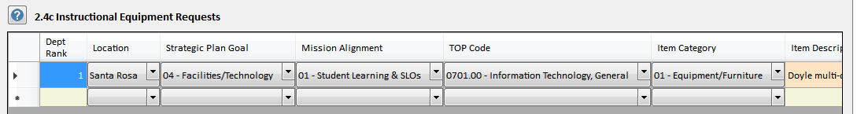

Rank for Instructional Equipment: Assign a numerical ranking that begins with the number 1 (1, 2, 3…).  Assign each item a separate rank (do not use any ranking more than once except to group related items that must be purchased together). Rank only those items that require funding. DO NOT rank those items for which you have confirmed funding and are including in this section only for documentation and planning purposes.

Location: Location where equipment will be used or installed.

Strategic Plan Goal: Choose from the drop-down menu one of the Strategic Plan Goals.

Mission Alignment:  Choose from the drop-down menu one of the focus areas from the District/College Mission Statement.

*NOTE:  The Sonoma County Junior College Mission Statement and Strategic Plan Goals and Objectives can be found on the Institutional Planning website at:* [*https://planning.santarosa.edu*](https://planning.santarosa.edu/)*.*

TOP Code:  Choose from the drop-down menu the TOP Code most closely related to your area.

Item Category:  Choose from the drop-down menu the category that best fits the item you are requesting. The definitions below may help you choose the appropriate category:

**Equipment/Technology:**   Instructional equipment for primary use by students in instructional programs. This may include classroom and laboratory equipment, whiteboards, projectors, computers, and multi-media learning equipment.  This may not include supplies, which are traditionally expendable items and are under $200.

**Equipment/Furniture:** Instructional furniture for use by students in instructional programs.  This may include classroom desks, tables, and chairs, as well as laboratory tables and student workstations.

**Adaptive Equipment** – Equipment used by students with disabilities to assist them in direct support of instruction.   

**Library Material** – Library resources and content vital to student learning across disciplines and curriculum.

Item Description: Brief, specific description of item requested.

Qty: Quantity requested

Cost: Cost, if known.  Check with Media Services or IT for pricing of commonly requested technology items.

Requestor: Usually the department chair

Room:  Room where equipment will be located

Contact:  The knowledgeable contact person who can explain the item that is needed.

Responsibility Code: Confirm that the code presented is correct.

Activity Code: Confirm that the Activity Code presented is correct.

Funding Source: Choose from the drop-down menu the funding source that best fits the item you are requesting.

**When seeking bond funding through the ITG (Institutional Technology Group) refer to the guidelines below:**

ITG requests should only include technology equipment (software is not funded with ITG funds).

**When seeking funding through IELM (Instructional Equipment/Library Materials) refer to the guidelines below:**

To meet IELM categorical funding guidelines,instructional equipment is defined as equipment that is used in the classroom in support of instruction, such as media equipment, computers, lab equipment, media enhanced classroom audio-visual technology, chairs, and desks. This does not include instructional supplies, which are consumable in nature and cost less than $200 per item: For a full description of IELM Guidelines, see page 38 of this document: <https://acrobat.adobe.com/link/review?uri=urn:aaid:scds:US:f5bf380b-e52e-39b7-9de7-f9e3ab6e3ff7>

**Definition of Instructional Equipment:** The California Community College Chancellor’s Office states that instructional equipment is “for instructional and/or library or learning resource activities involving presentations and/or hand experience to enhance student learning and skill development.”  It is furniture, equipment, or technology that is used directly to serve students in an instructional setting. Equipment is defined as “tangible District property of a more or less permanent nature that cannot be easily lost, stolen, or destroyed but which replaces, modernizes or expands an existing instructional program.”  Furniture may be included, but land, buildings, and licensed motor vehicles are excluded. A handy way to see if equipment qualifies as instructional equipment rather than supplies is to answer the five questions below.  If you answer yes to any of them, the item should be classified as supplies rather than equipment.

1.     Does the item lose its original shape and appearance with use?

2.     Is it consumable, with a normal service life of less than one year?  Does it last less than two years?

3.     Is it easily broken, damaged or lost in normal use?

4.     Is it usually more feasible to replace it with an entirely new unit than to repair it?

5.     Is ~~it an inexpensive item? Does the small unit cost make it inadvisable to inventory the item?~~ the item under $500?

The IELM allocation process occurs in the fall semester with purchasing deadline in spring.

**II.            INSTRUCTIONS FOR SUPERVISING ADMINISTRATORS**

After the PRPP is submitted by an Editor, Supervising Administrators are asked to rank the instructional equipment in their cluster PRPPs in order of priority~~, and~~.

**HOW TO RANK ALL THE REQUESTS IN YOUR CLUSTER**

Log in to PRPP

Open up one of the PRPPs in your cluster, except for your own Dean PRPP. Do not open your Dean PRPP, as this will not allow you to retrieve and rank all the requests from different departments in your cluster at once.

Click on the Excel icon toolbar button at the top of the screen to bring up the Export Spreadsheet Data screen.

Click the “editing is disabled – enable editing” toolbar button on the Export screen (6th from the left) to enable editing. The red X on the toolbar button icon will disappear.

Click the leftmost toolbar button on the Export screen to bring up the Select Records screen. The Component and Sub Component (Cluster) options will be grayed out and set to the name of your cluster. The Program/Unit option will default to all the program/units in your cluster. The screen should look like this:

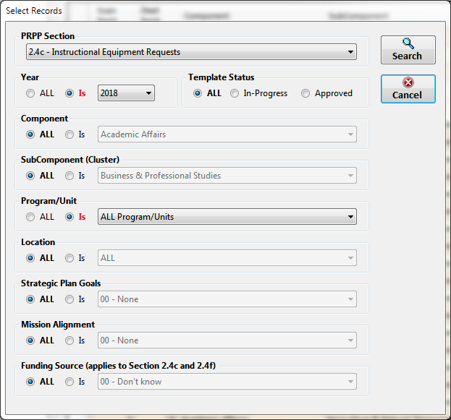

Note: A new search option “Funding Source” has been added to this screen and is enabled when Section

2.4c or 2.4f is selected.

Select the PRPP section you want to rank and click the Search button. All the requests in your cluster will be displayed in the grid. You can then add your cluster rankings in the Supv Rank column. You cannot add or delete records from the grid but you can edit the other columns if necessary. The grid should look like this:

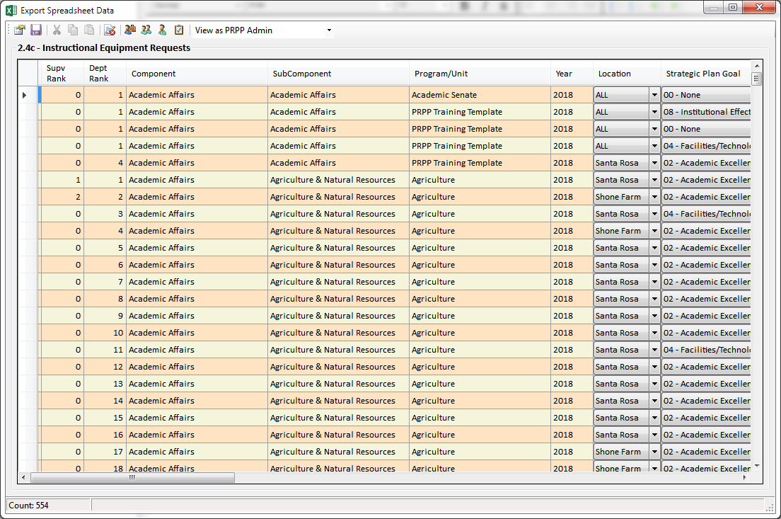

List your instructional Equipment requests in **rank order**, in the table provided.

Rank for Instructional Equipment: Assign a numerical ranking that begins with the number 1 (1, 2, 3…).  Assign each item a separate rank (do not use any ranking more than once except to group related items that must be purchased together). Rank only those items that require funding. DO NOT rank those items for which you have confirmed funding and are including in this section only for documentation and planning purposes.

Verify that a Funding Source has been selected for each item: Choose from the drop-down menu the funding source that best fits the item you are requesting. Combined funding sources have been added. This allows requestors to have the item considered for multiple funding sources.

After the ranking is complete, all items are exported to a master database for allocation based on available funds.

**III.          ALLOCATION PROCESS**

**Instructional Equipment/Library Materials (IELM)*:*** IELM funded recommendations are submitted by the Dean of Learning Resources to the appropriate vice president to finalize the priorities for their areas.

**CTEA and Bond Funding:** Funding for CTEA/Perkins and Bond Technology allocations are handled through grant and committee processes not defined in this document.

**ITG:** These requests will be reviewed by the ITG committee and VPs for recommendation for approval by the President.

**NOTE:** In identifying your instructional equipment and software needs, please make sure to include any additional costs ~~for meeting the needs of people with disabilities~~ related to inclusion and universal design, and for any impacts related to safety or facilities including the need for additional space, power, ventilation or plumbing.

**2.4d Non Instructional Equipment and Technology Requests (Update every spring)**

**2.4d Non-Instructional Equipment and Technology Requests**

Non-instructional equipment and technology includes new office computers ~~including faculty desktop computers, technology, desks, file cabinets, office furniture, maintenance equipment, or vehicles~~. Some examples of non-instructional technology include:

* Technology like digital signage, outdoor music system, speakers for emergencies, gaming equipment for students to use for socializing, other technology equipment that is not directly educational but used on campus.
* Technology equipment related to the network, e.g., switches, wireless access points, battery backups, servers.

List your Non-Instructional Equipment and Technology requests in the table provided.

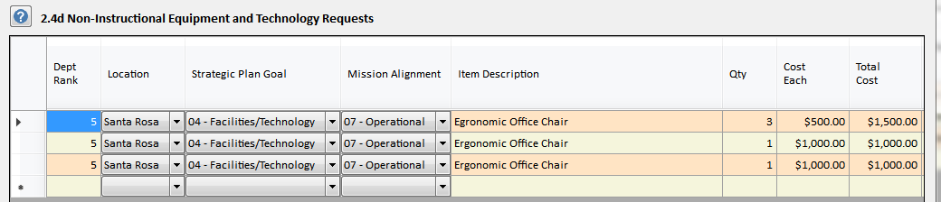

**Rank for Non-Instructional Equipment and Technology**: Assign a numerical ranking that begins with the number 1 (1, 2, 3, 4…). Assign each item a separate rank (do not use any ranking more than once except to group related items that must be purchased together).

Item Description: Be as specific as possible given the 100 character limit. Make sure to provide a full description and justification in the 2.4 Narrative section.

Location: Location where equipment will be used or installed.

Item Description: Brief, specific description of item requested. Please include “ITG” in the description for technology related requests, e.g., computers and network equipment.

Strategic Plan Goal: Choose from the drop-down menu one of the Strategic Plan Goals.

Mission Alignment: Choose from the drop-down menu one of the focus areas from the District/College Mission Statement.

*NOTE: The Sonoma County Junior College Mission Statement and Strategic Plan Goals and Objectives can be found on the Institutional Planning website at:* [*http://planning.santarosa.edu*](http://planning.santarosa.edu)*.*

Qty: Quantity requested

Cost: Cost, if known. Check ~~Media~~ ~~Services website at http://www.santarosa.edu/media~~ [[Media Services website](https://media.santarosa.edu/)](https://media.santarosa.edu/) for commonly requested media items.

Requestor: Usually the department chair

Room: Building and room where equipment will be located

Contact: The knowledgeable contact that can explain the need.

**II.            INSTRUCTIONS FOR SUPERVISING ADMINISTRATORS**

After the PRPP is submitted by an Editor, Supervising Administrators are asked to rank the instructional equipment in their cluster PRPPs in order of priority~~, and~~.

**HOW TO RANK ALL THE REQUESTS IN YOUR CLUSTER**

Log in to PRPP

Open up one of the PRPPs in your cluster, except for your own Dean PRPP. Do not open your Dean PRPP, as this will not allow you to retrieve and rank all the requests from different departments in your cluster at once.

Click on the Excel icon toolbar button at the top of the screen to bring up the Export Spreadsheet Data screen.

Click the “editing is disabled – enable editing” toolbar button on the Export screen (6th from the left) to enable editing. The red X on the toolbar button icon will disappear.

Click the leftmost toolbar button on the Export screen to bring up the Select Records screen. The Component and Sub Component (Cluster) options will be grayed out and set to the name of your cluster. The Program/Unit option will default to all the program/units in your cluster. The screen should look like this:

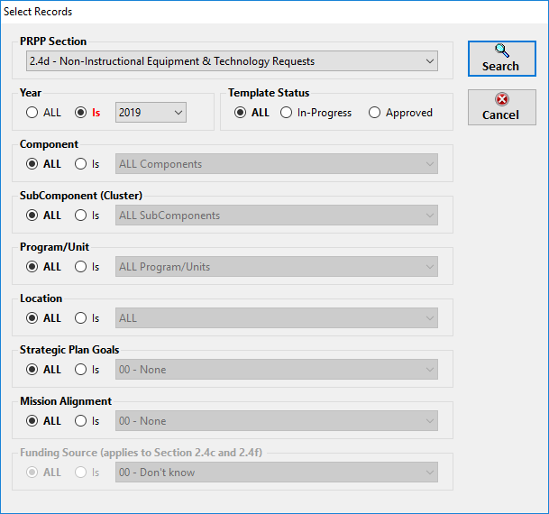

Note: A new search option “Funding Source” has been added to this screen and is enabled when Section

2.4c or 2.4f is selected.

Select the PRPP section you want to rank and click the Search button. All the requests in your cluster will be displayed in the grid. You can then add your cluster rankings in the Supv Rank column. You cannot add or delete records from the grid but you can edit the other columns if necessary. The grid should look like this:

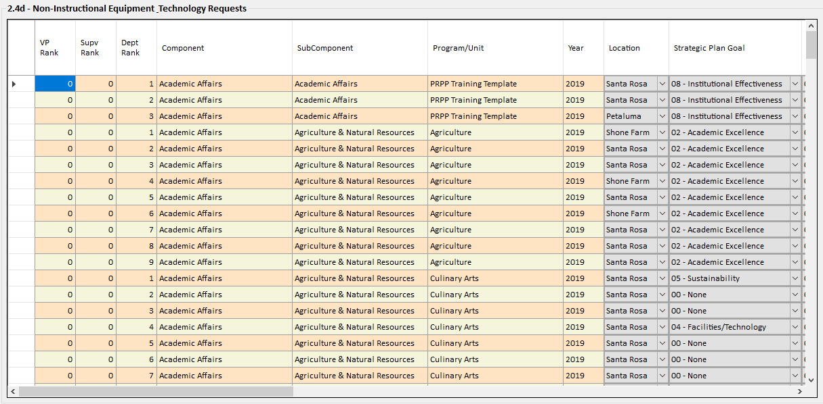

List your Non-Instructional Equipment requests in **rank order**, in the table provided.

Rank for Non-Instructional Equipment: Assign a numerical ranking that begins with the number 1 (1, 2, 3…).  Assign each item a separate rank (do not use any ranking more than once except to group related items that must be purchased together). Rank only those items that require funding. DO NOT rank those items for which you have confirmed funding and are including in this section only for documentation and planning purposes.

Verify that a Funding Source has been selected for each item: Choose from the drop-down menu the funding source that best fits the item you are requesting. Combined funding sources have been added. This allows requestors to have the item considered for multiple funding sources.

**2.4e Safety, ADA Compliance, and Ergonomic Issues (if applicable)**

**Do not enter information here.**

*Explanation: Reports must be initiated via the following link on the Environmental Health and Safety Department website:* [*https://www.santarosa.edu/ehs/safety-report/*](https://www.santarosa.edu/ehs/safety-report/)*. To report a safety, ADA compliance or ergonomic issue, use this link.*

*The PRPP does not generate the report.*

***Safety:*** *Any employee with a serious, immediate safety concern should report that when it occurs and not in the PRPP.*

***ADA Compliance:*** *The Americans with Disabilities Act (ADA) requires that all individuals have physical access to materials, programs, buildings, classrooms and offices. ADA concerns are gathered and forwarded on to the District Accessibility Committee (DAC) for prioritization. Please note that priorities are addressed first by highest need and second whenever construction takes place in a building; therefore, you may not see your concern addressed immediately.*

***Ergonomic Issues:*** *Ergonomics is the science of fitting the work environment to the worker. To report problems with work stations that are affecting health or productivity, fill out the form and a representative from Environmental Health and Safety will contact the affected individual for an ergonomic evaluation.*

**2.4f Instructional/Non-Instructional Software**

*Use this section to record requests for software only.*

**I.              INSTRUCTIONS FOR EDITORS:**

List your instructional/non-instructional Software requests in **rank order**, in the table provided.

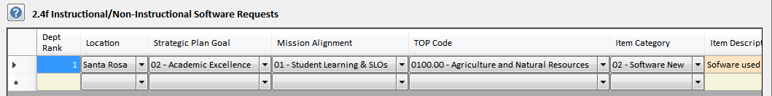

Please note that in almost all circumstances, software is NOT eligible for ITG funding.

Rank for Software: Assign a numerical ranking that begins with the number 1 (1, 2, 3…) Assign each item a separate rank (do not use any ranking more than once except to group related items that must be purchased together).  Rank only those items that require funding. DO NOT rank those items for which you have confirmed funding and are only including in this section for documentation and planning purposes.

After the ranking is complete, all items are exported to a master database for allocation based on available funds.

Location: Location where software will be used or installed.

Strategic Plan Goal: Choose from the drop-down menu one of the Strategic Plan Goals.

Mission Alignment:  Choose from the drop-down menu one of the focus areas from the District/College Mission Statement.

*NOTE:  The Sonoma County Junior College Mission Statement and Strategic Plan Goals and Objectives can be found on the Institutional Planning website at:* [*http://planning.santarosa.edu*](http://planning.santarosa.edu)*.*

TOP Code:  Choose from the drop-down menu the TOP Code most closely related to your area.

Item Category:  Make sure you have indicated Item Category “02-Software New” or “03-Software Renewal for these selections. The definitions below may help you choose the appropriate category:

**Software/New** – First-time purchase of department-related software for use in instructional and non-instructional programs. Include the cost of a single year subscription.

**Software/Renewal** – Ongoing, department-related software that is currently in use in instructional and non-instructional programs. Include the cost of a single year subscription.

Item Description: Brief, specific description of item requested.

Qty: Quantity requested

Cost: Cost, if known.  Check with IT for assistance in getting cost estimates.

Requestor: Usually the department chair

Room:  Room where equipment will be located

Contact:  The knowledgeable contact person who can explain the item that is needed.

Responsibility Code: Confirm that the code presented is correct.

Activity Code: Confirm that the Activity Code presented is correct.

Funding Source: Choose from the drop-down menu the funding source that best fits the item you are requesting. **IELM funds may be used for the first year of an instructional software subscription, but may not be used to fund subsequent, ongoing software subscriptions**.

**II.            INSTRUCTIONS FOR SUPERVISING ADMINISTRATORS**

After the PRPP is submitted by an Editor, Supervising Administrators are asked to rank the software in their cluster PRPPs in order of priority

**HOW TO RANK ALL THE REQUESTS IN YOUR CLUSTER**

Log in to PRPP

Open up one of the PRPPs in your cluster, except for your own Dean PRPP. Do not open your Dean PRPP, as this will not allow you to retrieve and rank all the requests from different departments in your cluster at once.

Click on the Excel icon toolbar button at the top of the screen to bring up the Export Spreadsheet Data screen.

Click the “editing is disabled – enable editing” toolbar button on the Export screen (6th from the left) to enable editing. The red X on the toolbar button icon will disappear.

Click the leftmost toolbar button on the Export screen to bring up the Select Records screen. The Component and Sub Component (Cluster) options will be grayed out and set to the name of your cluster. The Program/Unit option will default to all the program/units in your cluster. The screen should look like this:

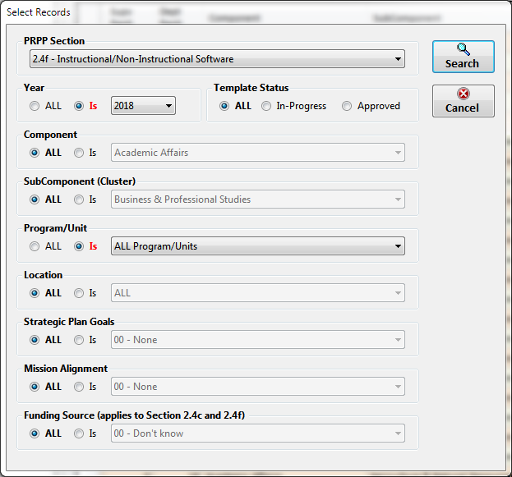

Note: A new search option “Funding Source” has been added to this screen and is enabled when Section

2.4c or 2.4f is selected.

Select the PRPP section you want to rank and click the Search button. All the requests in your cluster will be displayed in the grid. You can then add your cluster rankings in the Supv Rank column. You cannot add or delete records from the grid but you can edit the other columns if necessary. The grid should look like this:

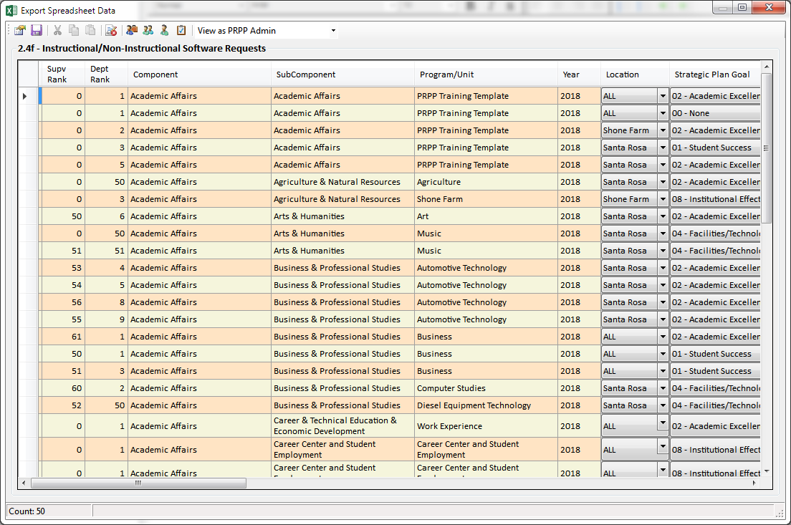

List your instructional/non-instructional Software requests in **rank order**, in the table provided.

Rank for Software: Assign a numerical ranking that begins with the number 1 (1, 2, 3…) Assign each item a separate rank (do not use any ranking more than once except to group related items that must be purchased together).  Rank only those items that require funding. DO NOT rank those items for which you have confirmed funding and are only including in this section for documentation and planning purposes.

Verify that a Funding Source has been selected for each item: Choose from the drop-down menu the funding source that best fits the item you are requesting.

After the ranking is complete, all items are exported to a master database for allocation based on available funds.

**2.5 Facilities Needs**

**2.5a Minor Facilities Requests**

***Process****: This list below exports to a master spreadsheet that will be prioritized by the supervising administrator(s) and then the appropriate Cabinet administrator; generally a Vice President. The needs of each component then move forward for discussion with Facilities Operations to determine feasibility and cost. Generally speaking, a* ***minor facilities request*** *is an upgrade or changes to an area, such as an upgrade to a single classroom, several classrooms, the wing of a building, or an office suite. If the program/unit needs a* ***cosmetic*** *upgrade to a small space, such as paint, carpet, or drapes, to a single classroom or one or two offices, those can be submitted as a Service Request (see* [*http://facilities.santarosa.edu/*](http://facilities.santarosa.edu/) *for more information about service requests and who to contact at each site). Provide an estimated cost if you can, but if not, leave that column blank. Facilities Operations will determine the costs of any high priority projects.*

Rank: Assign a numerical ranking (1, 2, 3, 4…). Assign each item a separate rank (do not use any ranking more than once)

Location: Campus or site

Time Frame: Choose from drop-down menu

Strategic Plan Goal: Choose from the drop-down menu one of the Strategic Plan Goals.

Mission Alignment: Choose from the drop-down menu one of the focus areas from the District/College Mission Statement.

*NOTE: The Sonoma County Junior College Mission Statement and Strategic Plan Goals and Objectives can be found on the Institutional Planning website at:* [*http://planning.santarosa.edu*](http://planning.santarosa.edu)*..*

Building or Proposed Location: Existing building or a new, proposed building

Room Nbr or Space: Room number or description such as “playing fields” or “vineyard”

Description of Need and/or Service Requested: Very briefly state the need for the facility. This information exports to a master spreadsheet, so keep it brief.

**2.5b Analysis of Existing Facilities**

***Process****: The District Accessibility Committee (DAC) reviews and prioritizes these requests as part of a ten-year plan to address physical issues of accessibility. Your request will be added to their agenda for consideration and compared to other needs in the District.*

* If existing facilities are not adequate, please explain.
* If applicable, explain what improvements or spaces are needed.

**SECTION 3: ALIGNMENT WITH COLLEGE-WIDE GOALS AND STRATEGIC PLAN**

**3.1 Develop Financial Resources**

In this section, list anything that your program/unit has done in 2013-14 or 2014-15 in support of the following Strategic Plan Goal and strategic objectives:

**Goal G: Develop Financial Resources**

Pursue resource development and diversification while maintaining responsible fiscal practices and financial stability, including:

* Increase the amount of discretionary, unrestricted general fund local revenue
* Increase and maintain the District reserves above the state requirements
* Pursue alternative funding sources including grants, partnerships, and scholarship s to support our diverse communities and students
* Manage enrollment and course offerings to maximize apportionment funding

**3.2 Serve Our Diverse Communities**

In this section, list anything that your program/unit has done in 2013-14 or 2014-15 in support of the following Strategic Plan Goal and strategic objectives:

**Goal C: Serve our Diverse Communities**

Serve our diverse communities and strengthen our connections through engagement, collaboration, partnerships, innovation, and leadership.

* Identify the educational needs of our changing demographics and develop appropriate and innovative programs and services with a focus on the increasing Latino/a population.
* Contribute the richness of our multicultural community by promoting cultural initiatives that complement academics and encourage the advancement and appreciation of the arts.
* Meet the lifelong educational and career needs of our communities (e.g. seniors, merging populations, veterans, re-entry students).
* Provide relevant career and technical education that meets the needs of the region and sustains economic vitality.

**3.3 Cultivate a Healthy Organization**

In this section, list anything that your program/unit has done in 2013-14 or 2014-15 in support of the following Strategic Plan Goal and strategic objectives:

**Goal F: Cultivate a Healthy Organization**

Cultivate an inclusive and diverse organizational culture that promotes employee engagement, growth, and collegiality.

* Foster an environment focused on collegiality and mutual respect in regards to cultural and individual perspectives.
* Recruit and hire outstanding faculty and staff and implement an exemplary Professional Development Program for all employees.
* Establish robust programs to improve the health and wellness of students and employees.
* Increase safety planning, awareness, and overall emergency preparedness.

**3.4 Safety and Emergency Preparedness**

*Provide responses to all three of the following:*

* **Injury and Illness Prevention Program (IIPP)**

The District’s Injury and Illness Prevention Program is found in District Policy 6.8.2 and Procedure 6.8.2P. This program needs to be reviewed with each employee at least once per year. Identify the steps that have been taken to review this program with employees in your department this year. Contact Environmental Health and Safety if you need assistance (524-1654).

* **Safety Trainings**

Per the District Injury and Illness Prevention Program (IIPP), what safety trainings does your department require? Contact Environmental Health and Safety if you need assistance (524-1654).

* **Building and Area Safety Coordinators**

List your Building and Area Safety Coordinators as shown in the sample below. Include Name, Building, Building Safety Coordinator (BSC) Area, Area Safety Coordinators (ASC) Area, Department, and any specific areas of responsibility.

*Writers Tip: Outside of the PRPP template, create a word table or excel table in the following format, and then paste it into this text block.*

|  |  |  |  |  |  |  |  |  |
| --- | --- | --- | --- | --- | --- | --- | --- | --- |
| **Building** | **BSC**  **Area** | **ASC Area** | **Name** | **Department** | **Responsible Area** | | **Management Support** | |
| #100 Jacobs | B/100 | A/100-1 | John Jones | Petaluma DRD | 1st Floor- DRD | Lauralyn Larsen | |

**3.5 Establish a Culture of Sustainability**

In this section, list anything that your program/unit has done in 2013-14 or 2014-15 in support of the following Strategic Plan Goal and strategic objectives:

**Goal E: Establish a Strong Culture of Sustainability**

Establish a culture of sustainability that promotes environmental stewardship, economic vitality, and social equity.

* Expand, support, and monitor district-wide sustainability practices and initiatives.
* Infuse sustainability across the curriculum and promote awareness throughout District operations.
* Promote social and economic equity in the communities we serve.
* Ensure economic sustainability by leveraging resources, partnering with our

Describe and quantify how your department, program, or unit contributes to SRJC’s Sustainability Goal. Consider curriculum, office practices, purchasing, building operations and maintenance, and other green practices. When specific budget, staffing, facilities, equipment or technology resources are required, please submit those requests in Section 2: Resources. For more information go to: [www.santarosa.edu/sustainability](http://www.santarosa.edu/sustainability).

**SECTION 4: STUDENT LEARNING OUTCOMES**

**4.1a Course Student Learning Outcomes (SLOs)**

Note: This section only applies to programs/units that offer courses.

* SLO assessments are now archived in the SLO Assessment Share Point site. Be sure all program/unit assessments are posted there. For instructions, go to the SLO website at <http://slo.santarosa.edu/>
* How have course SLO assessment results over the past three years, including the current year, been used to improve student learning at the course level? (Note: All assessments should be documented in the SLO Assessment Tracking System in SharePoint.)
* ACCJC Accreditation Standards require an ongoing, systematic assessment of all courses and programs. Within each 7-year accreditation cycle, SRJC must establish documented improvements in student learning where warranted.

**4.1b Program Student Learning Outcomes (SLO) Assessment**

Note: This section applies only to programs/units that offer certificates or majors.

* ACCJC Accreditation Standards require an ongoing, systematic cycle of assessment of all certificates and majors, even low-unit certificates. At SRJC, our cycle is that all of the SLOs in every certificate/major must be assessed at least once every seven years.
* For information and instructions on how to assess certificate and major SLOs, go to this web site:

<http://slo.santarosa.edu/certificates-majors-slo-assessment>

* In the text block provided, describe your department/discipline seven-year cycle of assessment. You can copy and paste into the text block a chart or a spreadsheet, which might be the easiest thing to do.
* What certificates/majors(s) has the program/unit assessed over the past three years?
* How have the results been used to improve student learning at the certificate/major level?

**4.1c Student Learning Outcomes Reporting (Section Deleted)**

This section has been deleted. SLO’s are reported on SRJC’s SLO Sharepoint website (see <https://slo.santarosa.edu/> for more information).

**4.1d Instructions:**

* Enter all current courses and its number (e.g. English 1A).
* For each course, please indicate the semester you plan to assess one or more course SLOs.
* Each course should have at least one term added, but you can add multiple terms if you are planning more than one assessment term.
* The assessment plan is flexible and can be adjusted as necessary. Its purpose is to ensure that each course is assessed every four years.

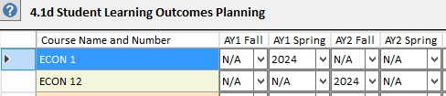

**4.2a Key Courses or Services that Address Institutional Learning Outcomes**

SRJC District faculty, staff and students collaboratively developed seven institution-level learning outcomes. As a District, we expect all students to develop competencies in these areas. Please indicate how your program supports the achievement of these outcomes.

In the column headings of the table provided, input the names of the key courses (or services) in your program/unit (e.g., general education courses, courses in a pre-requisite sequence, heavily enrolled courses, services to students) and simply indicate by putting an “X” in the appropriate box which institutional learning outcomes are addressed in each of the courses.

For your reference, here is the list of SRJC’s Institutional Learning Outcomes:

**Institutional Student Learning Outcomes (I-SLOs)**

1a **Perform mathematical operations** (Foundational Skills)

1b **Utilize technology** (Foundational Skills)

1c **Read and write at the college level** (Foundational Skills)

2a **Develop self-awareness and confidence** (Personal Development and Management)

2b **Manage resources, such as time and money, in order to advance personal and career goals** (Personal Development and Management)

2c **Maintain or improve health** (Personal Development and Management)

2d **Appreciate the value of lifelong learning** (Personal Development and Management)

3a **Listen actively and respectfully** (Communication)

3b **Speak coherently and effectively** (Communication)

4a **Locate, analyze, evaluate, and synthesize relevant information** (Critical Analysis)

4b **Draw reasonable conclusions in order to make decisions and solve problems** (Critical Analysis)

1. **Creatively respond to ideas and information** (Creativity)

6a **Recognize and acknowledge individual and cultural diversity** (Intercultural Literacy and Interaction)

6b **Practice respectful interpersonal and intercultural communication** (Intercultural Literacy and Interaction)

6c **Recognize and understand the ideas and values expressed in the world’s cultural traditions** (Intercultural Literacy and Interaction)

7 **Understand and demonstrate personal, civic, social, and environmental responsibility and cooperation in order to become a productive local and global citizen** (Responsibility)

**4.2b Narrative (Optional)** (for academic program/units or units offering courses, certificates, and majors only)

Explain how your program/unit has participated in dialogue about SLOs over the past three years.

**SECTION 5: PERFORMANCE MEASURES**

**5.0 Program/Unit Workload and Performance Measures**

This section allows programs/units to define and report on their own unique workload and performance measures. The program/unit should identify any unique **non-academic** data elements that provide insight into the quantity and quality of the services you provide. Trend data is particularly helpful.

You can copy and paste tables or charts in the text block provided. If section 5.0 is not relevant to you, just state “not applicable.”

*EXAMPLES:*

* *Human Resources could measure the number of recruitments each year or the number of applications processed.*
* *A&R could report on the number of student applications processed each year.*
* *A student service might measure the number of the number of student visits (duplicated headcount) or number of students who have utilized services (unduplicated headcount).*
* *The Library could measure student visits or other performance measures, such as student use of electronic databases.*

**Sections 5.1 through 5.11: Instructional Programs ONLY**

**These prompts apply only to programs/units that offer courses.**

* There are two PRPP templates: Academic and non-Academic.
* Section 5.0 is for programs/units that have unique, non-academic data.
* Sections 5.1 through 5.11 are for program/units that have academic data, that is, they offer classes and generate data such as FTES, FTEF, headcount, retention, GPA, etc.
* To change your template, contact Patty Collis, Information Technology at [pcollis@santarosa.edu](mailto:pcollis@santarosa.edu).
  1. **Effective Class Schedule: Course Offerings, Times, Locations and Delivery Modes**

To interpret these data, look for patterns, especially an increase, decrease, or relative stability in student headcount. This is **duplicated** headcount, which means that every enrollment is counted and the same student may be counted more than once. Sometimes it is helpful to look at fall-to-fall and spring-to-spring comparisons. Review your data and address the questions below:

* Is the program offering a **balanced** class schedule convenient to students with day, evening, Friday, and weekend courses, as needed? Explain.
* Is the program offering a good **geographic distribution** of classes, at Santa Rosa, Petaluma, Public Safety Training Center, and other sites? Explain.
* Does the program effectively use **alternative delivery modes** when appropriate such as online, online hybrid, or video transmission? Explain.
* Is there demand for specific courses that is not being met? If so, what is the plan to address this?
* Could the program do a better job of serving students, and if so, how? State specific recommendations.
* If the program/unit has a pattern or trend of declining or unstable enrollments over the past four years, what adjustment of course scheduling has the program implemented to address this? (For example, changing times of day, block scheduling, online offerings, short courses, adjusting frequency and number of sections, open entry-open exit classes, or rotation plans.)
* Are course offerings being scheduled frequently enough or in rotation to assure that students can complete the program within the stated duration of the program or within a “reasonable” time frame (often interpreted to be two years, but it could be longer)?
* Describe any marketing efforts or outreach activities geared to increasing enrollments, if applicable.

To answer these questions, review the following data:

* Academic Data Report 5.1: Student Headcounts
* Enrollment Reports (Program/units must save these each semester from the SIS or go to the Academic Affairs reports in SIS and look for the historical archive)
* Data Mine/Enrollment Management System: For a more detailed analysis, programs/units can utilize data mining or the Enrollment Management System (EMS). If you need assistance with data mining or EMS, contact your supervising administrator.

**5.2 Enrollment Efficiency and Average Class Size**

**5.2a Enrollment Efficiency/Fill Rate**

Enrollment efficiency, also known as fill rate, is a measure of the percentage of seats filled at first census based on the class limit (not the room size). Enrollment efficiency provides some evidence about how effectively the schedule is developed. The District goal for enrollment efficiency is **95% or more** of seats filled at first census based on class limit for fall or spring and **85**% for summer.

If your enrollment efficiency (fill rate) is **below 85%**, consider the following questions:

* Is the department scheduling more sections than demand warrants, particularly multiple sections of the same course?
* If the discipline has certificates or majors that are heavily sequenced or have many course requirements, could the required courses be offered on a rotation plan so that students secure the courses that they need within a one, two, or three year time frame? If so, students should be kept informed of the pattern.
* Does the program appeal primarily to day students or to evening students? Do you see different patterns of enrollment in day or evening that should be addressed?
* Could this program benefit from offering some sections online or through other delivery mechanisms, where greater flexibility might attract more students?

If your enrollment efficiency (fill rate) is **above the efficiency goal**, explain briefly how you maintain that efficiency.

If your enrollment efficiency (fill rate) is **very** **near or over 100%**, it is quite possible that courses or programs are impacted. Consider the following questions:

* Can more courses be added to serve student needs?
* Is the discipline impacted for lack of instructors? If so, you should address your recruitment challenges (Section 2.3d) and perhaps justify the need for more full-time faculty (Section 2.3e).
* Is the discipline impacted for lack of space? If so, please explain your space needs and also include requests for new or additional space (Section 2.5a and 2.5b).

To answer these questions, review the following data:

* Academic Data 5.2a: Enrollment Efficiency. The percentage of seats filled in each discipline at first census based on class limit (not room size).

**5.2b Average Class Size**

Average class size is the average number of students enrolled in all sections at first census (total enrollment at first census divided by the number of sections, excluding cancelled sections). Average class size can be an important factor for faculty staffing requests. Class size may be based on past practice, but there are often other reasons as well. If so, explain those.

* Explain any trends in average class size, whether increasing or decreasing.
* Explain any limits on class size, such as pedagogical limits, regulatory mandates, or facilities constraints.

To answer these questions, review the following data:

* Academic Data 5.2b: Average class size in each discipline at first census (excludes cancelled classes).

**5.3 Instructional Productivity**

The Instructional Productivity Ratio is defined as FTES divided by FTEF (see explanation below). The District goal for productivity is at least 17.5 full-time equivalent students for each full-time equivalent faculty member, a ratio of 17.5 to 1. On an annual basis, that would be 35 FTES per FTEF. What this means is that on average each instructional faculty member is able to teach 17.5 full time equivalent students each semester or **35** full-time equivalent students per academic year.

* If your program’s productivity ratio is **lower than 17.5**, explain any circumstances that contribute, such as limitations of facilities, regulations, special pedagogy, or scheduling challenges.
* If your program’s productivity ratio is **17.5 or higher**, describe how you maintain that productivity.
* Explain any trends that you see in productivity.
* Recommend ways the program could improve productivity.

*Analysis Tips: For most purposes, such as schedule development or PRPP, Academic Affairs generally looks at productivity per semester or per term.*

***FTES:*** *Full-Time Equivalent Students (FTES) is a way of expressing enrollments in terms of equating enrollment with full-time students. A full-time student is assumed to attend classes for 525 hours per year (15 hours per week x 35 weeks = 525).*

***FTEF:*** *Full-Time Equivalent Faculty (FTEF) is the total instructional load of all faculty in a given time frame (usually a semester), including both full-time and part-time faculty. For example, 1.0 FTEF = 100% load or 4.25 FTEF = 425% load. FTEF data reflects instructional load* ***only*** *and does not include reassigned time, such as department chair reassigned time.*

***Instructional Productivity Ratio:*** *The instructional productivity ratio is FTES divided by FTEF (FTES/FTEF). This ratio relates faculty load to the number of full-time equivalent students served. Ideally, the college as a whole should have an instructional productivity of at least 17.5 per term****.*** *This productivity is roughly achieved when the average class size for lecture is 35 and the average class size for lab is 25. Class sizes may vary in different disciplines due to the pedagogical demands, and in general courses with larger class sizes help to balance out courses with smaller class size.*

**5.4 Curriculum Currency**

Academic Affairs will provide a list of the curriculum for each discipline and when it was last reviewed. All curriculum should be reviewed on a six-year cycle. Curriculum that has not been reviewed in the past six years needs to go through a full review and be brought current. It is helpful if the department chair or program coordinator develops a plan and assigns specific faculty with the necessary expertise to update certain courses.

* Is the curriculum current? (Current means that each course has been updated within the last SIX academic years, although courses submitted for articulation to UC should be reviewed within the past FIVE years, especially if seeking articulation.)
* If not, what is the plan to bring curriculum current?
* On the curriculum spreadsheet provided, delete any courses from the lists that are no longer active or that you will not offer in the future. Send this list of deletions to the office of the Dean of Curriculum, Educational and Support Services.

To answer these questions, review the following data: Curriculum Currency Spreadsheet (data provided by Academic Affairs Curriculum Office)

**5.5 Successful Program Completion**

* Describe any course sequencing or course rotation plans that allow a student to complete their certificate/degree/major in a reasonable time frame.
* Does the program offer support or services to help students complete certificates, licensure, or majors? If so, describe those.
* Review the trends in numbers of degrees or certificates awarded, and, if possible, explain the trend. Data are posted on the PRPP web site: [www.santarosa.edu/prpp](http://www.santarosa.edu/prpp).
* If available and applicable, provide data about student success rates on licensure exams or external/industry examinations or certifications. (Note: you can copy and paste that information into this text block.) If applicable, recommend ways to improve certificate, licensure and major completion overall and by targeted groups, as appropriate. “Targeted groups” could be defined by gender, age, ethnicity, disability status and income.
* If these data are available, what has been the history of employment or job placement following the certificate or majors in your program/unit? What is the employment outlook over the next three years? If applicable, recommend ways to improve employment or job placement.

To answer these questions, review the following data:

* Number of certificates awarded, trend (posted on the PRPP web site: [www.santarosa.edu/prpp](http://www.santarosa.edu/prpp)).
* Number of majors awarded (posted on the PRPP website: [www.santarosa.edu/prpp](http://www.santarosa.edu/prpp)).
* Number of licenses secured and the trend (program/unit must provide).

**5.6 Student Success**

* How does student **retention** at the discipline level compare to the overall District **retention** rate? (Retention means the student remained in the class to the end of the semester and received a grade in the course that is an A, B, or C, D, Pass or Incomplete).
* How does student **success** at the discipline level compare to the overall District **success** rate? (Success means the student achieved a successful grade in the course that an A, B, or C, or Pass).
* How does the average student GPA at the discipline level (total units/grade points) compare to the overall District GPA? If there is a difference (either above or below), can you explain that?

To answer these questions, review the following data:

* Retention: See Academic Data 5.6a.
* Successful Course Completion: See Academic Data 5.6b.
* Grade Point Average: See Academic Data 5.6c.
* Occupational Programs Only (optional). Completion of “capstone” or advanced course in a sequence signifying attainment of job skills. Course to be identified by the program. (Data Source: Data mine. The program/unit must provide this information using data mine and drilling down to course level for headcount. If assistance is needed, contact the supervising administrator.)
* Student Equity Data: Student Equity data provides information on Retention, Successful Course Completion, and Grade Point Average disaggregated by ethnicity, gender, age, income level, disability status, college status and basic skills.

Student Equity data reports are found in a separate folder and should not be confused with Academic Data. To view District and discipline averages for the Student Equity measures, go to the main PRPP website for data: [www.santarosa.edu/prpp](http://www.santarosa.edu/prpp) and click on the most recent “Academic Affairs Docs” folder. This will open a new window. Find the “Student Equity Docs” folder. Within that folder, you will find District Totals as the first document on the list. Your discipline data can be found, in alphabetical order, listed below the District Totals document.

*Interpreting Student Equity Data*

* *All the data in the student equity tables are based on enrollments (same as in data mining). This is NOT an unduplicated head count; rather the numbers reflect grades associated with enrollments. If a student took more than one class in the same discipline in the same semester, that student would count more than once as they had more than one enrollment.*
* *Retention (Student Equity Data, Table 5.6a) is defined as end of semester enrollments with a grade of A, B, C, D,* Pass*, or Incomplete compared with enrollments as of first census.*
* *Successful Course Completion (Student Equity Data, Table 5.6b) is defined as end of semester enrollments with a grade of A, B, C, or* Pass *compared with enrollments at first census.*
* *Grade Point Average (Student Equity Data, Table 5.6c) is the average final grade assigned for all enrollments as of end of semester.*
* *Income Level uses BOG (Board of Governor’s) fee waiver as a proxy for the income level of students. Students who are BOG eligible can be considered low income compared with all other students.*
* *Disability Status is defined by a student’s official involvement with our Disability Resources Department in the year in question, meaning they have a verified disability and are receiving services.*
* *College Status is defined as first generation; that is neither parent having earned an Associate’s degree or higher.*
* *Basic Skills is defined by a student’s concurrent enrollment in a basic skills math, English or ESL course in the semester in question. Currently, basic skills math classes include all College Skills math courses; basic skills English includes College Skills English courses and 300-level courses in the English department; and ESL includes all credit ESL courses.*
* *A recommended approach is to first examine student equity data for your discipline, and then compare your data with the District-wide data.*
* *For example in the first table of the District Totals, Student Equity Data, Table 5.6a, in all of the student equity data documents, the percentages represent enrollments of students who were retained. The first cell of data shows the overall retention rate for all enrollments in that summer.*
* *The columns show data by semester, much like in data mining.*
* *The rows show the enrollments data broken down by student categories (ethnicity, gender, age, etc.)*
* *Technical note: For each cell in Student Equity Data, Tables 5.6a and 5.6b, the denominator reflects the total number of enrollments that fall into both the row and column categories for that cell. For example, on the District Totals table, the first line under ethnicity (White) and the first column of data (X20**, or summer 20**) produces numbers in a cell that are unique to those two categories (enrollments of white students in summer 20**). The numerator reflects the number of enrollments of white students who were retained that semester (X20**). The percentage in that cell represents the percent of all retained enrollment of white students in summer 20**.*

*Writing Tips*

* *What patterns to you see in retention, success, and GPAs for enrollments in your discipline? For example, it is common for retention rates to be higher in summer terms.*
* *What patterns do you see in your student equity data? Do you see differing levels of achievement by ethnicity, gender, socioeconomic status, or disability status?*
* *Next, it is recommended that you compare your data with the District-wide data. Do the patterns you identified in your disciplinary data mirror what you see in the District-wide data?*
* *What can your discipline faculty do to address the disparities you find in your data? Some ideas might include:*
* *Systematically referring low performing students to support services such as the Tutorial Center.*
* *Invite a counselor into your classroom to promote information about student support services, and share information about special support programs such as EOPS, Puente, MESA, etc.*
* Embedding study and research skills in your coursework.

**5.7 Student Access**

* Do students from diverse ethnic backgrounds enroll in the disciplines at rates equal to their participation rates in the District as a whole? If not, how could the program attract students that may be underrepresented in the program?
* Do students from diverse ethnic backgrounds enroll in the disciplines at rates equal to their participation rates in the District as a whole?
* Do male or female students constitute 75% or more in this discipline? If so, what strategies are being used or planned to increase enrollment of the non-traditional gender?
* Has the program/unit experienced changes to its student population or changes in the needs of students in the last four years?
* What types of outreach or retention efforts are occurring or should be implemented to better serve under-served or under-represented populations in this program?
* How does this program/unit serve students that are often underrepresented in college including various ethnic groups, lower socioeconomic groups, English language learners?

To answer these questions, review the following data:

* Students served by Ethnicity: See Academic Data 5.7a
* Students served by Gender: See Academic Data 5.7b
* Students served by Age: See Academic Data 5.7c
* Demographics of the students served by the District as a whole, for comparison, can be found in the Current Documents section, in the District Totals Academic document

**5.8 Curriculum Offered Within Reasonable Time Frame**

Title 5 regulations require that all courses for certificates and majors be offered within a “reasonable time frame.” A reasonable time frame is often considered to be two years, but it could be longer if appropriate. For example, a reasonable time frame for an evening program designed for working adults might be three years.

Are all courses in certificates and majors offered on a regular or rotational basis so that students can complete their programs within a reasonable time frame?

Are you course sequences (program maps) current on the majors/certificate website? If not, plan to update those.

To answer this question, review the following data:

* Enrollment at first census in each course by location, past four years (Data Source: Data mine. Chair must pull this information. For assistance, contact supervising administrator.)
* Number of sections offered each semester at which locations (Data source: Data mine -- use “course count” or “section count” data. Chair must pull this information. For assistance, contact supervising administrator.)
* If courses are offered in rotation, describe the rotation plan or copy and paste into the text area a schedule of course offering patterns. (Data Source: Program must provide.)

**5.9a Curriculum Responsiveness**

* How does the program/unit curriculum respond to changing student, community, and employer needs?
* Has your program/unit fully complied with the State requirement that every general education course that transfers to a CSU or UC campus must include objectives (content) related to gender, global perspectives, and American cultural diversity? If not, describe the plan to bring the curriculum into compliance.
* How does the curriculum support the needs of other programs, certificates, or majors?
* Offer recommendations and describe plans for new directions in the curriculum.

CTE Only:

* How many advisory committee members attend your meetings that represent industry?
* How many of these members represent industry and also serve as adjunct faculty?
* Is the diversity of membership on your advisory committee representative of the fields in which students will be entering upon completion of your degree, certificate or major? If not, what is your plan to diversify membership?
* In the past year, has the advisory committee reviewed your curriculum for currency?
  + If not, why?
  + If so, what changes were implemented as a result of this feedback?
* Does this position support collaborative efforts with other colleges in the region?

To answer these questions, review the following data:

* List of courses and course descriptions (Data Source: College catalog or the web.).
* Input from advisory committees (CTE programs only). (Data Source: Program/unit must provide.)

**5.9b Alignment with High Schools (Tech-Prep ONLY)**

* Does the program align with high school preparation?
* Are courses articulated with high school courses or part of a career pathway? (Data Source: Senior Dean, Career and Technical Education).
* Are courses articulated with high school courses or part of a tech prep or 2+2 agreement? (Data Source: Tech Prep Coordinator).

**5.10 Alignment with Transfer Institutions (Transfer Majors ONLY)**

* Do transfer majors align with (75% overlap of units) the lower division required courses at common transfer destinations? If not, what is the plan to bring the major into alignment?
* Do transfer majors align with (50% overlap with) the lower division required courses at common transfer destinations? If not, what is the plan to bring the major into alignment?

To answer this question, review the following data:

* Data Source: Go to [www.assist.org](http://www.assist.org) and review existing articulation agreements with at least three CSU or UC campuses that are common transfer destinations for SRJC students.

**5.11a Labor Market Demand (CTE Programs ONLY)**

As required by Title 5, section 78016, the Board must assure that each CTE career certificate or degree meets a documented labor market demand and does not represent unnecessary duplication of manpower training in the area.

* Provide the employment growth data (both number of job openings and percentage growth) in the Career and Technical Education Occupations(s) for which you are training for the most recently captured ten-year period as projected by the California Employment Development Department for Sonoma County. In addition, please include the average of the nine-county Bay Area. If you need assistance, please call the office of the Dean of Career and Technical Education and Economic Development at (707) 524-1792.
* As appropriate, please provide additional regional, and/or state labor market data as it relates to certificates, degrees and majors in this program/unit. You may cite any current sources of data that have informed your planning (e.g., newspaper articles, journals, Chancellor’s Office labor market studies written in the last two years, etc.). Please share any feedback related to labor market trends identified by your advisory committee.
* Which local community colleges (North Bay) and private higher education institutions provide a degree, certificate or major in the same discipline?

Data Source: Include documentation, such as EDI statistics (Data can be copied and pasted into the text block)

**5.11b Academic Standards**

* Does the program regularly engage in dialogue about academic standards? If so, describe any conclusions or plans.

**SECTION 6.0: PLANNING**

**6.1 Progress and Accomplishments Since Last Program/Unit Review**

This is your opportunity to “close the loop” on planning by reporting what your program/unit accomplished over the past year. Incomplete goals should be re-evaluated and carried forward, modified, or deleted.

Fill in the chart provided with the following:

Rank: Assign a numerical ranking (1, 2, 3, 4…). Assign each item a separate rank (do not use any ranking more than once).

Location: The location where the goal/objective was to be achieved.

Time Frame: The period of time period in which the goal/objective was to be achieved.

Strategic Plan Goal: Choose from the drop-down menu one of the Strategic Plan Goals.

Mission Alignment: Choose from the drop-down menu one of the focus areas from the District/College Mission Statement.

*NOTE: The Sonoma County Junior College Mission Statement and Strategic Plan Goals and Objectives can be found on the Institutional Planning website at:* [*http://planning.santarosa.edu*](http://planning.santarosa.edu)*.*

Goal: Goals you set in your program/unit PRPP last spring for this academic year have been ‘rolled’ into the section.

Objectives: Objectives you set in your program/unit PRPP last spring for this academic year have been ‘rolled’ into the section.

Progress to Date: Note your progress on each of your goals/objectives. Goals/objectives that are incomplete can be carried over into the next year.

**6.2b PRPP Editor Feedback (Required)**

Editors and approvers may use this section to provide feedback and suggestions to the PRPP Coordinating Committee about the PRPP process, template, data, or any other aspect of PRPP. Section 6.2b will serve as an ongoing assessment of the PRPP process and eliminates the need for separate user surveys distributed after the PRPP annual cycle. Information provided in Section 6.2b will be used by the PRPP Coordinating Committee to meet its commitment to continuous quality improvement.

**6.3a Annual Unit Plan**

List your plans for the next academic year (for major projects, you may need to project further into the future). To do this, go back through your PRPP document and identify areas that need improvement as well as goals and directions for the future. Include any goals or plans to reduce costs or share resources.

**If your plans include increased staff, equipment, or facilities requests, include those requests in the appropriate sections of this document.**

Fill in the chart provided with the following:

Rank: Assign a numerical ranking (1, 2, 3, 4…). Assign each item a separate rank (do not use any ranking more than once).

Location: The primary location where this goal/objective is to be achieved.

Time Frame: The period of time period in which goals and objectives will be achieved.

Strategic Plan Goal: Choose from the drop-down menu one of the Strategic Plan Goals.

Mission Alignment: Choose from the drop-down menu one of the focus areas from the District/College Mission Statement.

*NOTE: The Sonoma County Junior College Mission Statement and Strategic Plan Goals and Objectives can be found on the Institutional Planning website at:* [*http://planning.santarosa.edu*](http://planning.santarosa.edu)*.*

Goal: A specific goal the program/unit plans to achieve during the next academic year.

Objectives: The significant steps or actions needed to achieve the goal during the next academic year. Be brief and specify the most critical steps only.

Resources: Required resources, including responsible individual(s) and estimated costs (budget estimates for high priority projects will be determined at a future date). Be brief.

|  |
| --- |
| **APPENDIX**  **Strategic Plan Strategy**   1. NONE 2. **ACADEMIC QUALITY –** Support excellent teaching and maximize education learning outcomes. 3. **STUDENT SUCCESS AND SUPPORT –** Provide students with services, programs, and events in support of basic needs and educational goals in order to reduce student success equity gaps. 4. **RESPONSIVENESS TO OUR COMMUNITY –** ensure that SRJC is supporting the diverse educational, social, and economic needs of our community. 5. **CAMPUS CLIMATE AND CULTURE –** cultivating a campus climate and culture for individuals connected to the District that embodies our Mission, Vision, and Values statements. |
| **Goal Alignment**   1. NONE 2. **ACADEMIC QUALITY** – **Goal 1**: Ensure quality of courses and andragogy across disciplines and modalities. 3. **ACADEMIC QUALITY** – **Goal 2**: Inspire and prepare students for transfer, degree or certificate completion, and lifelong learning through critical thinking and civic engagement. 4. **STUDENT SUCCESS AND SUPPORT** – **Goal 1:** Build a culture and ecosystem that creates a sense of belonging and purpose for all students. 5. **STUDENT SUCCESS AND SUPPORT** – **Goal 2:** Leverage basic needs services in support of student success while at the college and in the community. 6. **RESPONSIVENESS TO OUR COMMUNITY** – **Goal 1:** Offer SRJC programming that impacts all members of our community. 7. **RESPONSIVENESS TO OUR COMMUNITY** - **Goal 2:** Provide equitable access to District opportunities in recognition of diversification in county population. 8. **CAMPUS CLIMATE AND CULTURE** – **Goal 1:** Formalize a campus climate that is culturally aware and prioritizes efforts in support of inclusion, diversity, equity, antiracism, and accessibility (IDEAA). 9. **CAMPUS CLIMATE AND CULTURE** – **Goal 2:** Promote a community culture of sustainability. |