How to rank all the requests in your cluster

Log in to PRPP

Open up one of the PRPPs in your cluster. It doesn’t matter which one. Do not open your Dean PRPP. The Dean PRPPs belong to Mary Kay’s cluster.

Click on the Excel icon toolbar button at the top of the screen to bring up the Export Spreadsheet Data screen.

Click the “editing is disabled – enable editing” toolbar button on the Export screen (6th from the left) to enable editing. The red X on the toolbar button icon will disappear.

Click the leftmost toolbar button on the Export screen to bring up the Select Records screen. The Component and SubComponent (Cluster) options will be grayed out and set to the name of your cluster. The Program/Unit option will default to all the program/units in your cluster. The screen should look like this:

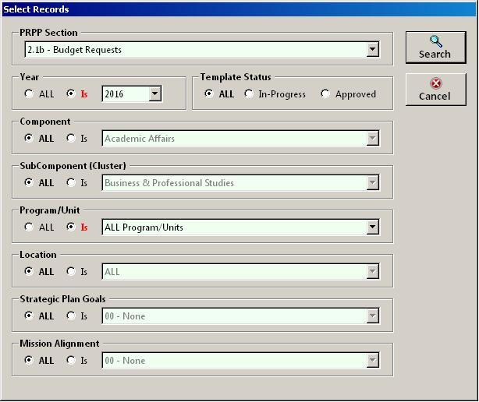

Select the PRPP section you want to rank and click the Search button. All the requests in your cluster will be displayed in the grid. You can then add your cluster rankings in the Supv Rank column. You cannot add or delete records from the grid but you can edit the other columns if necessary. The grid should look like this:

